**ASSIGNMENT 3**

**I have taken 2 input files- *schedule.txt*** *&* ***rr-schedule.txt* (For Round Robin & Priority Round Robin)**

**Taking (schedule.txt) input file for implementing all Scheduling Algorithms (FCFS,RR, Priority, Priority-RR, SJF):**

1. **Input File Content: schedule.txt**

T1, 4, 20

T2, 3, 25

T3, 3, 25

T4, 5, 15

T5, 5, 20

T6, 1, 10

T7, 3, 30

T8, 10, 25

**Implementation:**

1. First Come First Served (FCFS)

1. Round Robin (taking the Burst time: 3 milliseconds)

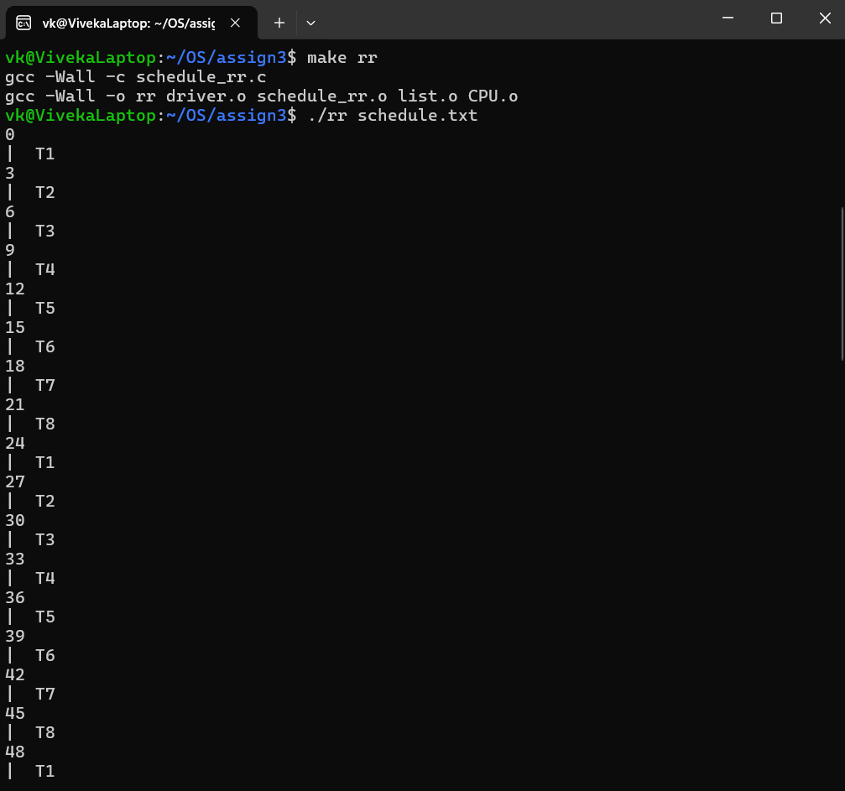

1. Shortest Job First (SJF)

1. Priority

Considering: Priorities range from 1 to 10, where higher numeric value indicates a higher relative priority.

1. Priority Round Robin (Taking Burst time: 3 milliseconds)

Considering: Priorities range from 1 to 10, where a higher numeric value indicates a higher relative priority.

**Taking (rr-schedule.txt) input file for implementing *Round Robin* & Priority *Round Robin*:**

1. **Input File Content: rr-schedule.txt**

T1, 40, 50

T2, 40, 50

T3, 40, 50

T4, 40, 50

T5, 40, 50

T6, 40, 50

1. Round Robin (taking Burst Time: 3 miliseconds)

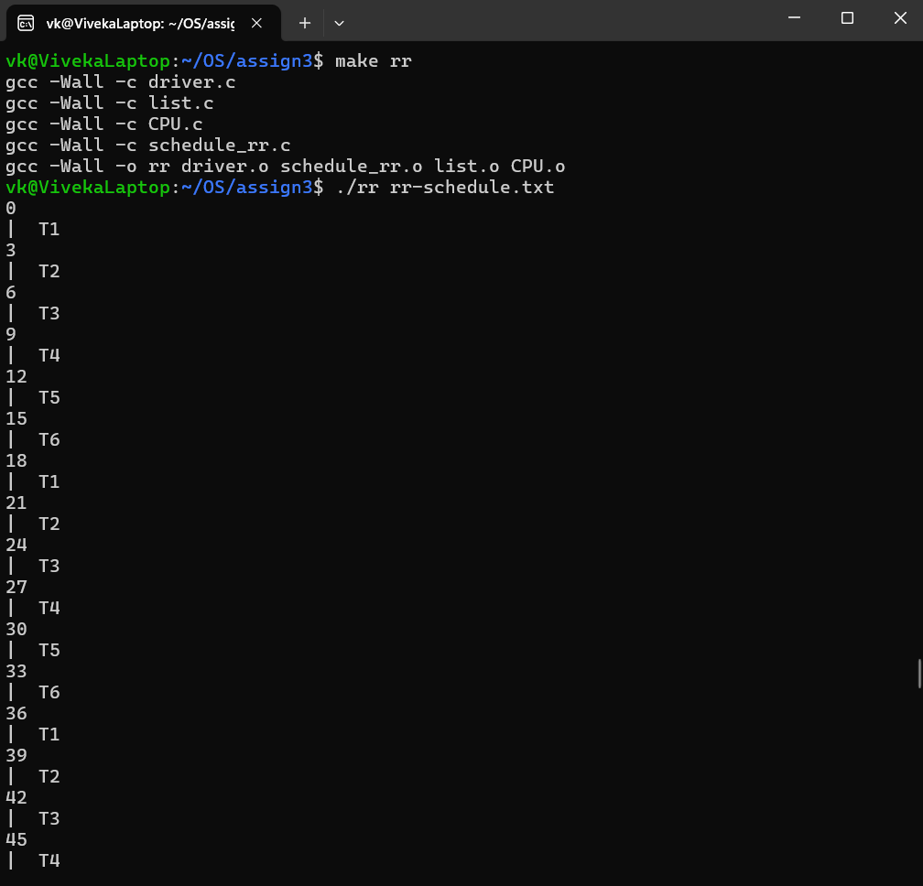

1. Priority Round Robin (taking Burst Time: 3 milliseconds)

Considering: Priorities range from 1 to 10, where a higher numerical value indicates a higher relative priority.



